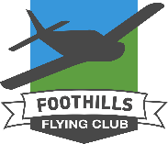
Foothills Flying Club (FFC)
Courtesy Car
Terms & Conditions: 1998 Jeep Grand Cherokee Laredo Licence Plate BVL7416
This vehicle is provided by the FFC for the use of itinerant pilots visiting the High River Airport (CEN4). The vehicle is insured with a 1M liability policy only, no comprehensive or collision. (Registration & insurance in the glove box)
- All drivers must hold a valid North American Drivers Licence with no more than 3 demerits.
- Please return the vehicle with fuel tank full and leave a donation towards our maintenance & insurance fund. (Suggested minimum donation $10.00)
- No smoking permitted in the courtesy vehicle
- Operators will be responsible for any traffic violations/tickets (Traffic cameras / Parking infractions)

Date: _______________ Day; ____________________ Month; _____________________ Year

Pilots Name: ____________________________________________________________________

Drivers Licence: ______________________; Expiry Date: ___________________________

Prov. /State: _________________________;

Pilot Licence: ________________________; Aircraft registration: __________________

Home Address: ____________________________________________________________________

__________________________________________________________________________________
Page over

Local destination: _______________________________________________________________

Time Out: ___________________________; Estimated Return: __________________________

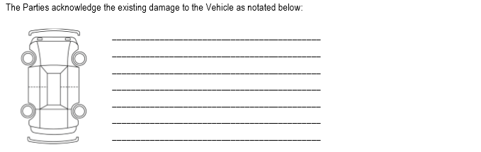

- Please take a picture of any damage and email: foothillsflyingclub@icloud.com

- Fuel gauge is sometimes intermittent, if fuel tank indicates empty – turn ignition switch off and back on while vehicle is stopped. This usually resets it.

Signature: ___________________________________________________________________________________
By signing this form I confirm my personal information is correct and I understand the terms & conditions

Drive Safe

www.foothillsflyingclub.com

Please deposit this form and your donation into the lock box

